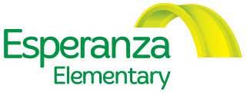
BOARD MEETING
6:00 – 6:30 PM, Thursday, September 07, 2017

MINUTES

***Phone conference, Dial in number (515) 739-1432, access code 383807***

WELCOME AND INTRODUCTIONS
BOARD MEMBERS PRESENT
Angela Zamora, Maria Parrilla de Kokal, Juan Freire, Patricia Matthews, Cody Case
MEMBERS ABSENT
Marty Banks [gave proxy vote to Juan], Janet Christensen [gave proxy vote to Juan], Debby Bauman, Challene Nuvan
OTHERS PRESENT
Eulogio Alejandre [Director of Esperanza]
ACTION ITEM
- Review & approve financial advisor bids for the Esperanza Elementary building
  - María made a proposal to accept Verapath as the financial advisor
    - Angela second
    - Motion did not pass: María, Janet & Angela vote “yes”
Patricia, Juan, Cody & Marty vote “no”

  - Patricia made a motion to adopt LYRB as the financial advisor. Motion carried.
    - Cody second
    - Motion did pass; Cody, Marty, Patricia & Juan voted “yes’
María, Janet & Angela voted “no”

NEXT MEETING
Will be held at Esperanza Elementary on Thursday, September 28, 2017

